# Exercise 1

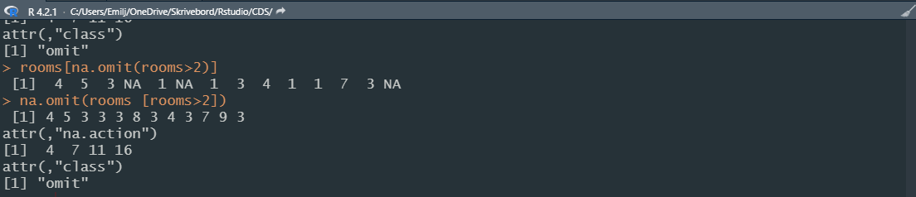

Code:  
rooms <- c(1, 2, 4, 5, 1, 3, 1, NA, 3, 1, 3, 2, 1, NA, 1, 8, 3, 1, 4, NA, 1, 3, 1, 2, 1, 7, 1, 9, 3, NA)

na.omit(rooms [rooms>2])

# exercise 2

code: class(rooms)

numeric

# exercise 3

Interviews <- read.csv("data/SAFI_clean.csv")



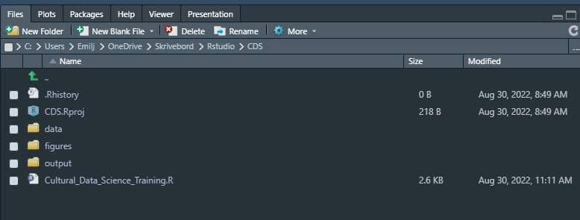

https://github.com/Digital-Methods-HASS/AU633260_Emil_B_Jacobsen